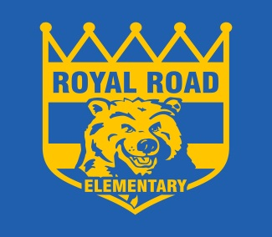
ROYAL ROAD ELEMENTARY SCHOOL
340 Royal Road, Fredericton, NB, E3G 6J9
http://royalroad.nbed.nb.ca
PHONE: (506) 453-5438
FAX: (506) 444-5268
Sheila Legere Principal
Mary Brophy Vice- Principal
To Learn, To Grow, To Lead
Music Notes
Royal Road Elementary
April 2019

Happy spring! Music classes at Royal Road Elementary are in the final stages as we head for summer and, as such, some exciting things are going on!

Building on all of our work surrounding beat and rhythm, the kids in Kindergarten, grade 1 and grade 2 are now incorporating those skills into singing and we are playing as many different instruments as possible. Throughout the rest of the year, we will spend time drums and other percussion instruments and hopefully be able to play some ukelele before year’s end.

The grades 3 through 5 are embarking on a major project to conceive, design and build their own musical instrument which they will then compose an original piece of music on and perform. Materials will be gathered from home and school and the project will be largely constructed in our music room. Please note that parents are NOT expected to purchase anything, as students are being strongly urged to use their creativity in designing something where most, if not all, materials are readily available.

Thank you so much for supporting your child’s interest in music – they are skills that will help them in language acquisition, mathematics and creativity. Most of the instruments we use are also relatively inexpensive and can be picked up at any of the local music stores. A life of music is, after all, extraordinarily rich, builds bonds between people, and keeps us young!

Thanks again!
Andrew Titus

